X Class

**L 200 154 004**

**RARA KINANDHA NINGRUM**

Computer Organization & Architecture

Perform a binary multiplication operation (4 bits) between the number 14 multiplied by 15:

a. Calculate by means of human thinking

b. Calculate by using computer (ALU)

c. What is the result of a = b?

a. Calculate by means of human thinking

1110

1111 x

1110

1110

1110

1110

11010010

b. Calculate by using computer (ALU

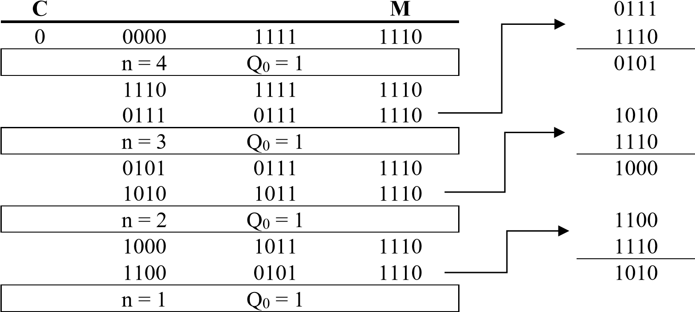 **A Q**

0

0

1

0

1

0

1 1010 0101 1110

|  |  |
| --- | --- |
| 1101 | 0010 |

0 1110

c. What is the result of a = b?

Yes. The intermediate results using the human way and by the computer (ALU) are the same.